Below are iterations of our requirements and target specifications documents. Note the management section is collapsed as it encompasses items pertaining to the concept selection review. These documents are presented in reverse chronological order and represent meaningful progress instead of precise weekly intervals. Requirement document dates are September 22, October 6, and 28. Target Specifications document dates are September 9, 16, 22, and October 6. For context, the below stakeholders summary document summarizes the actual needs of major and minor stakeholders.

Stakeholder Summary

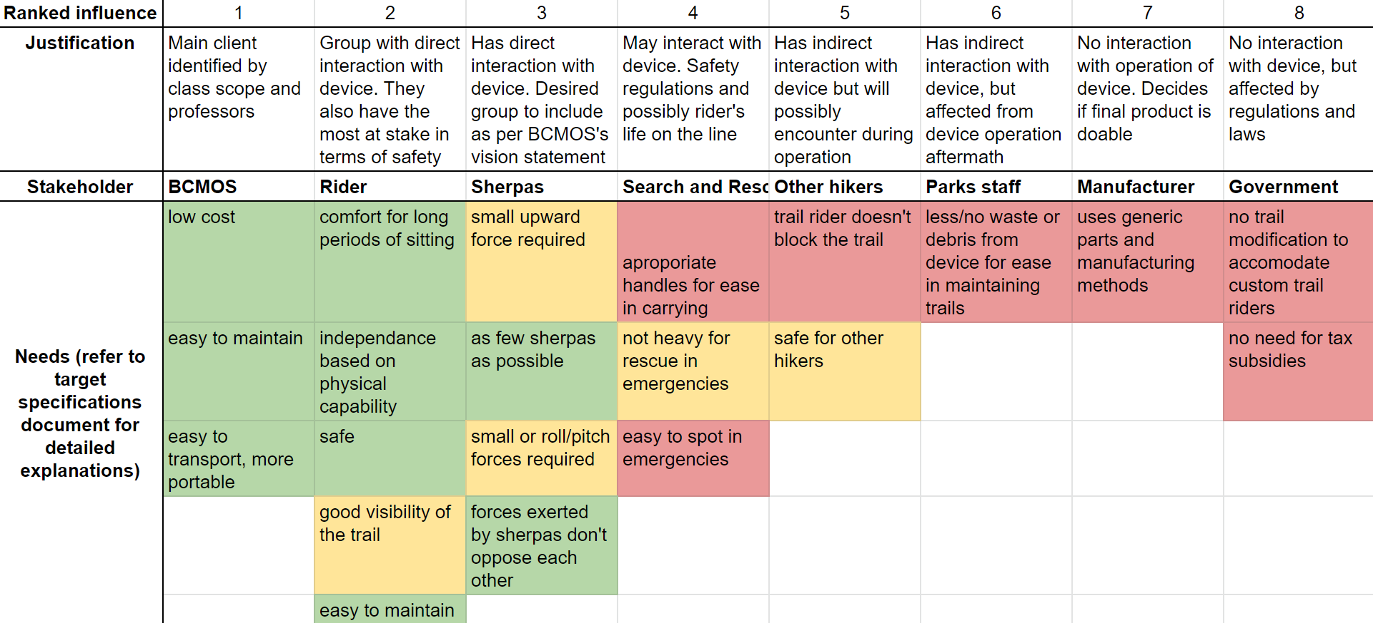

Requirements [October 28, 2019]

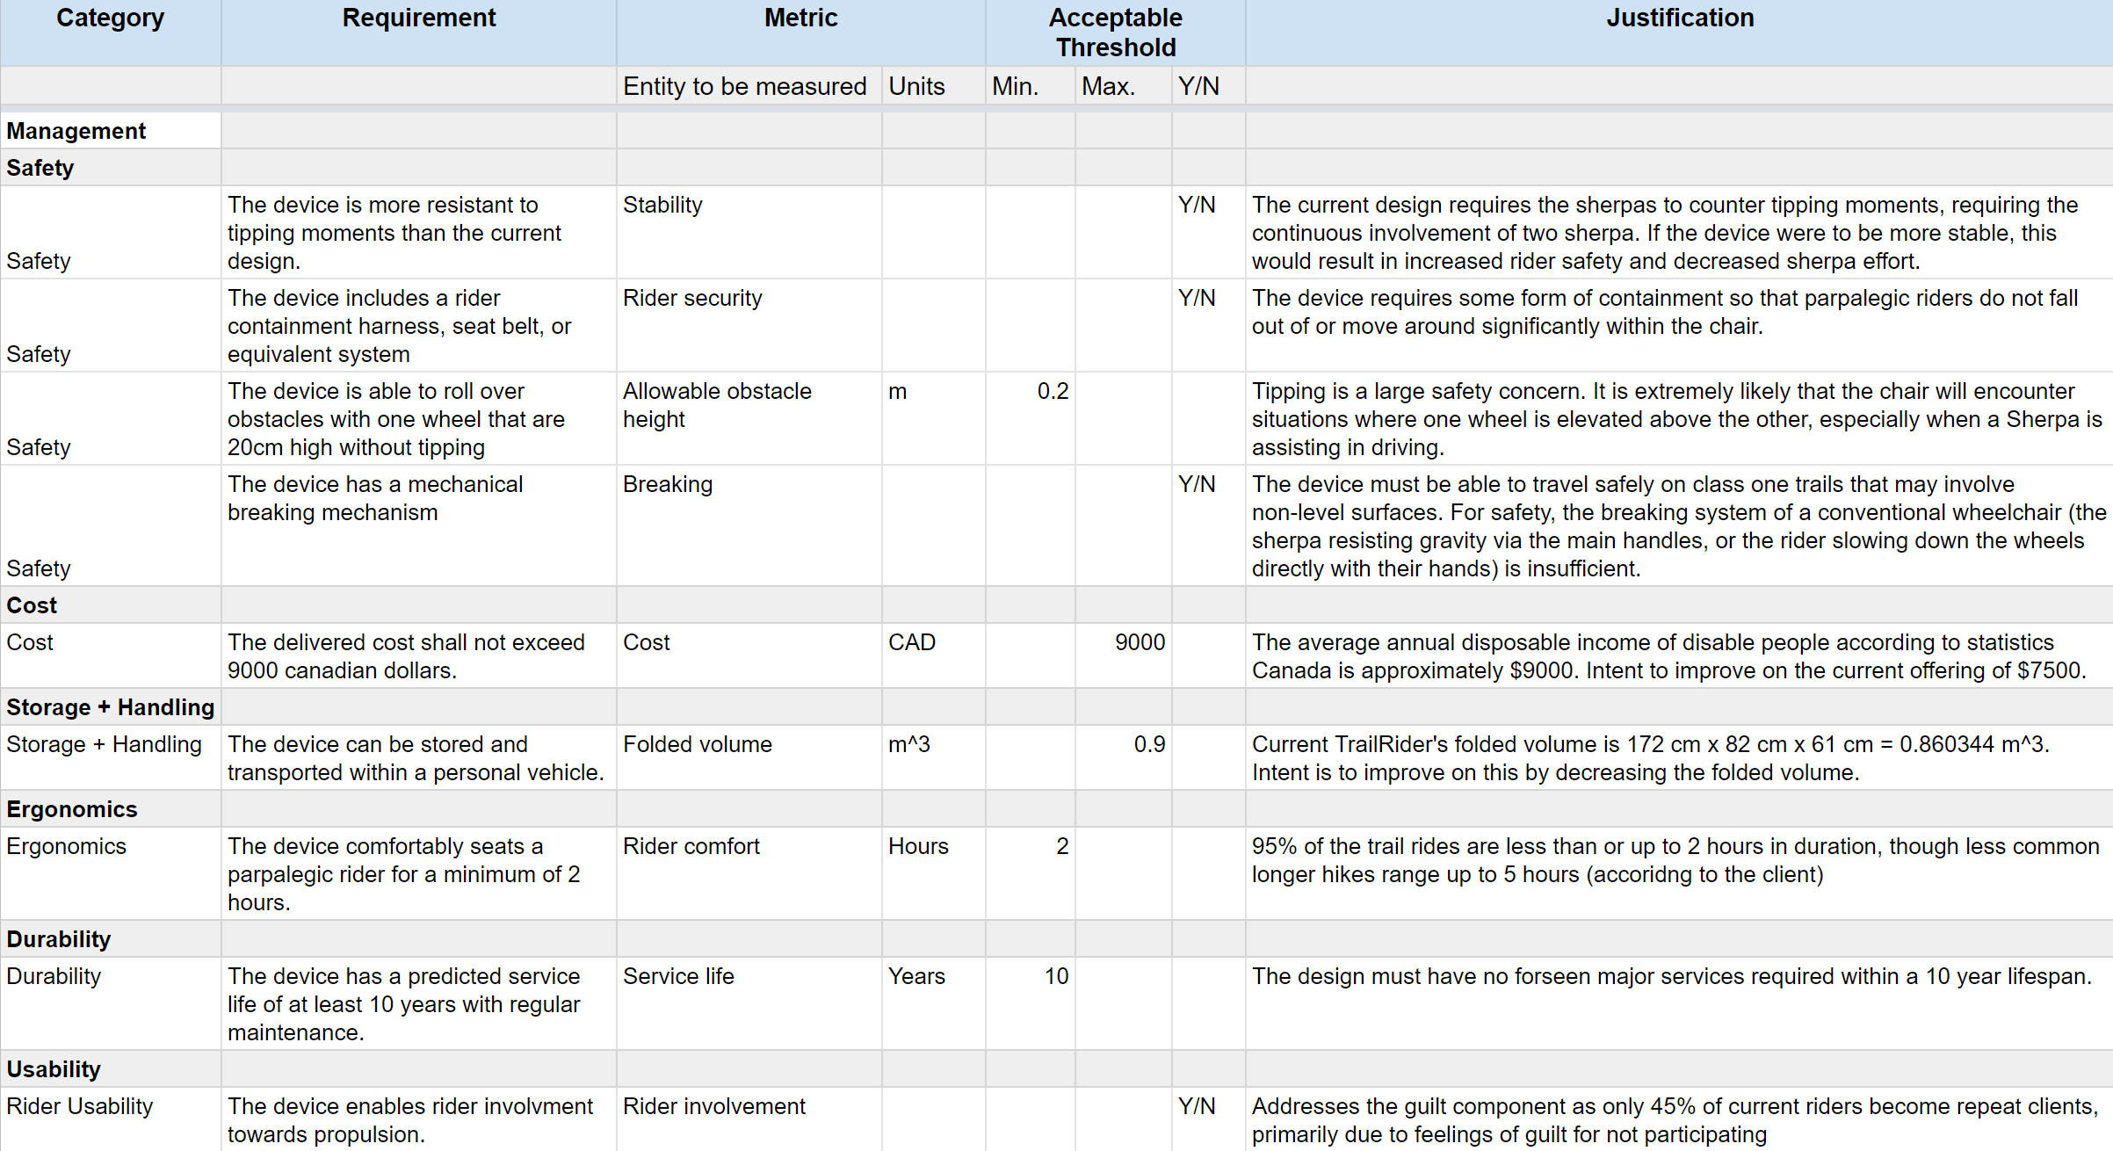

Requirements [October 6, 2019]

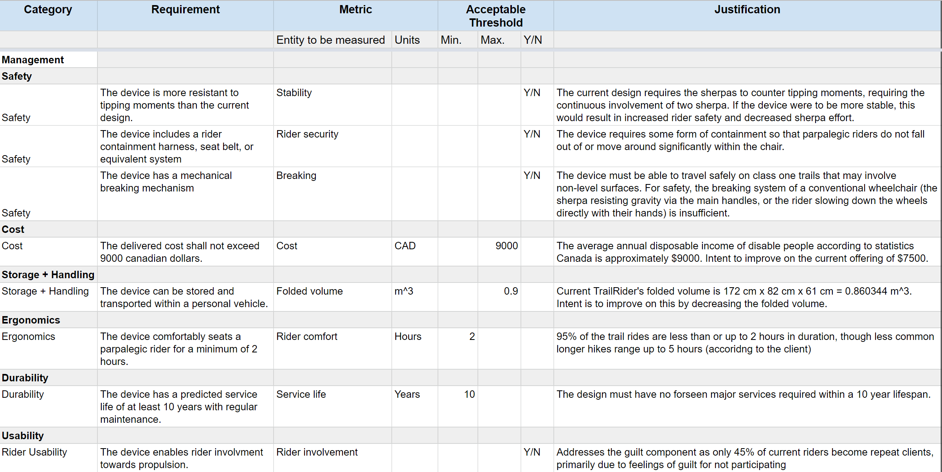

Requirements [September 22, 2019]

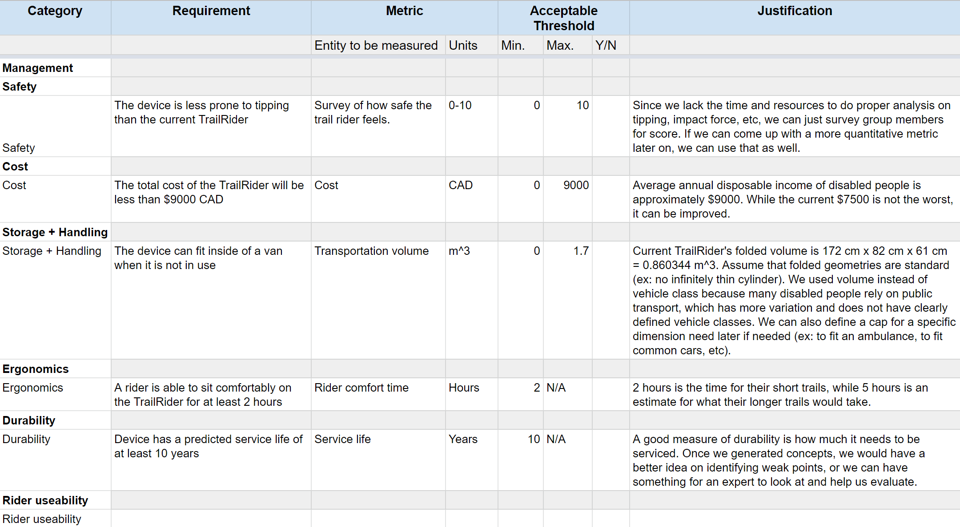

Target Specifications [October 6, 2019]

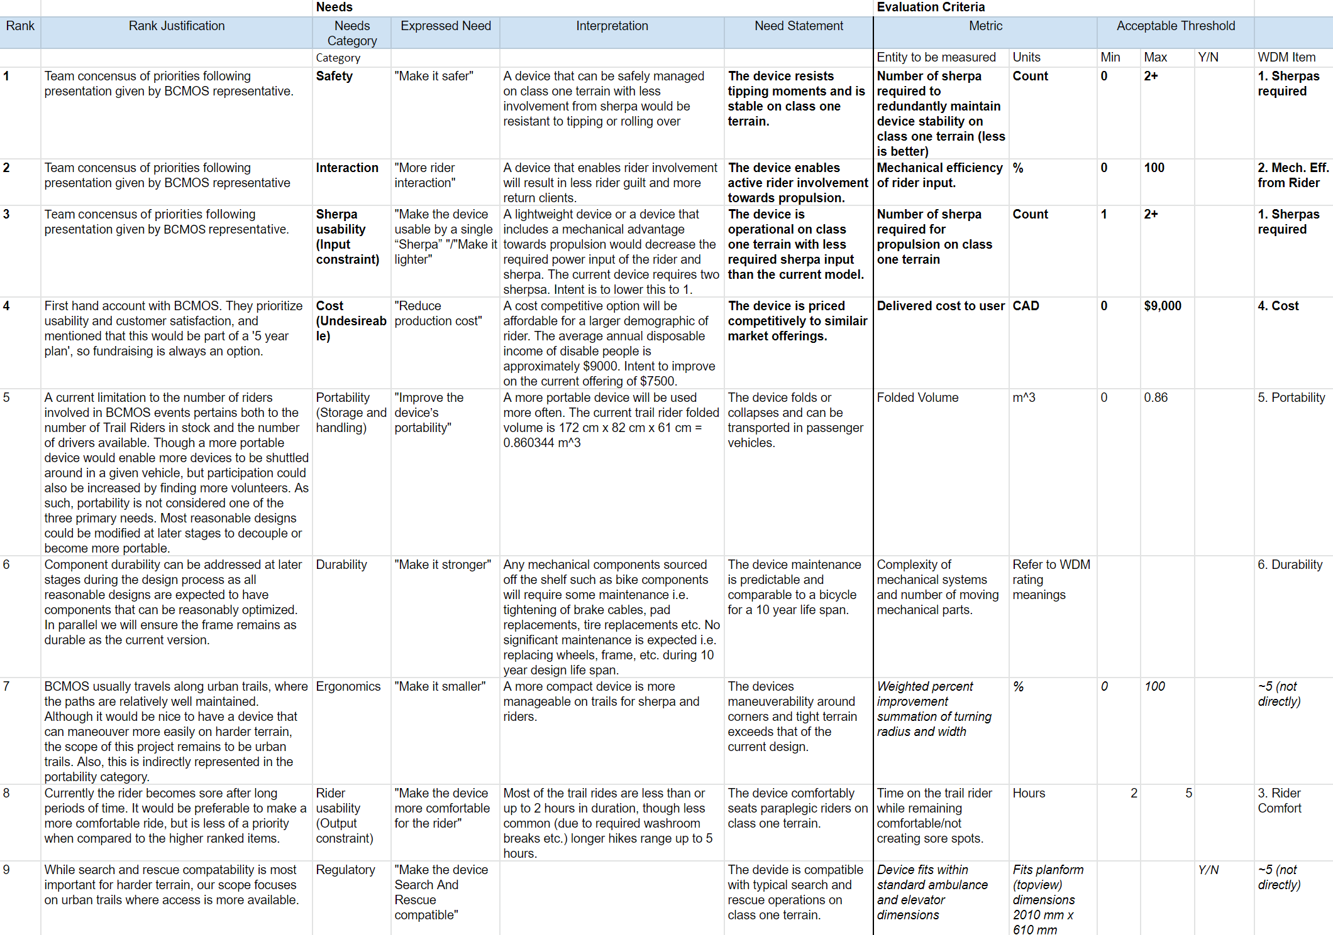

Target Specifications [Septmeber 22, 2019]

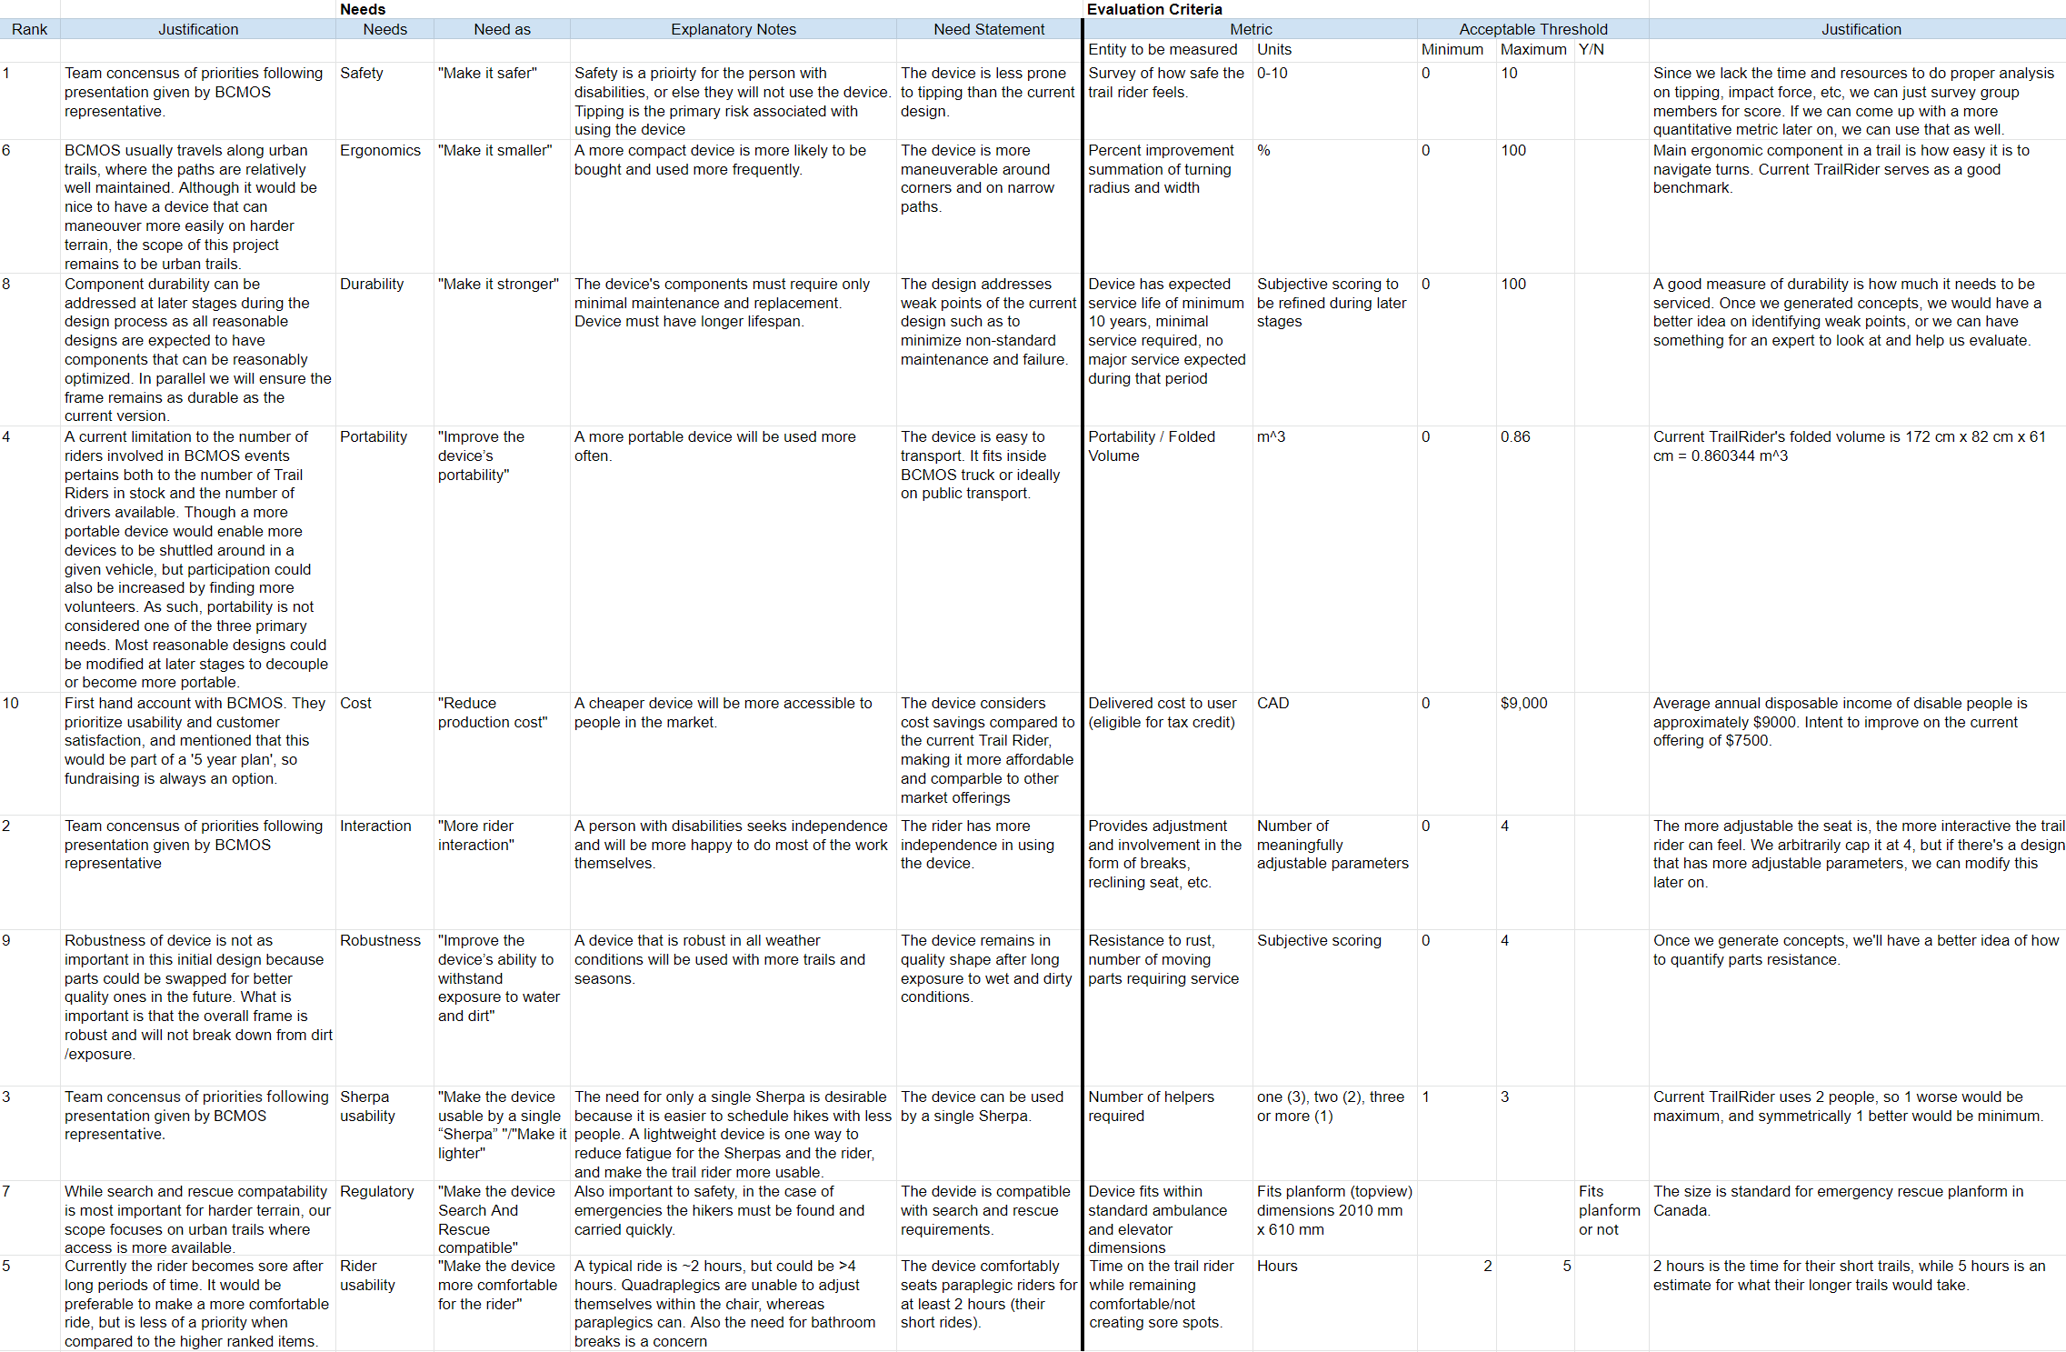

Target Specifications [Septmeber 16, 2019]

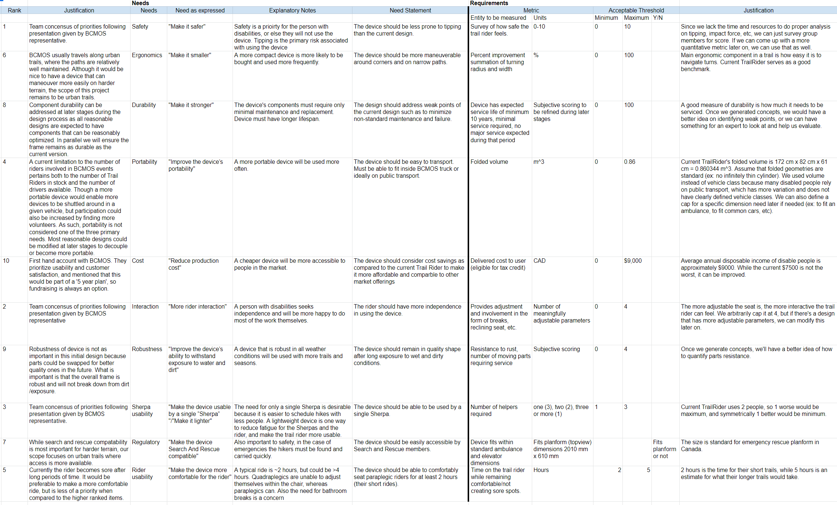

Target Specifications [September 9, 2019]

